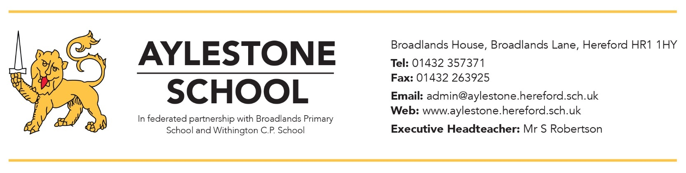

Exam Equipment Information for Students

All students MUST bring the following to EVERY timetabled written exam: -
• At least two BLACK ballpoint pens, you are not permitted to write in any other colour in Public exams. (Please make sure they work!)
• HB Pencil
• 30CM clear plastic ruler
• Rubber
• Sharpener
• Any required medication (this should be clearly marked with your name, handed into an invigilator at the start of the exam and collected at the end)

GCSE Subjects requiring additional Equipment
Triple & Combined Science – Scientific calculator required (All papers)
Business – Scientific calculator required (Both Papers)
DT Textiles & DT Graphics – Scientific calculator & protractor required
Geography - Scientific calculator required (All papers)
Maths Foundation & Higher - Scientific calculator (Papers 2 & 3 only), protractor & compass required

